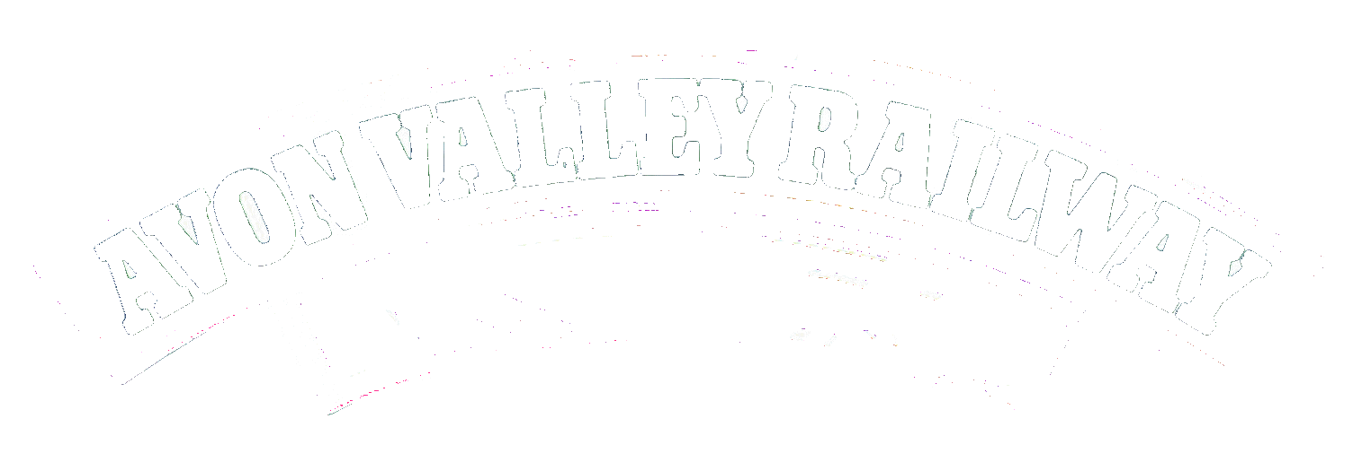

Industrial Mixed Traffic Gala
Saturday16th of March
This one-day mixed traffic gala will see up to 6 locomotives in operation, hauling a variety of passenger and freight trains throughout the day. The traction will be drawn from our pool of operational industrial steam and diesel locos alongside Hudswell Clarke No 1742. Driver for a fiver will be in operation during the event along with brake van rides and Footplate rides (Last two require booking)
The line-up:
• Hudswell Clarke 0-4-0ST No 1742
(Courtesy of Buckinghamshire Railway Centre)
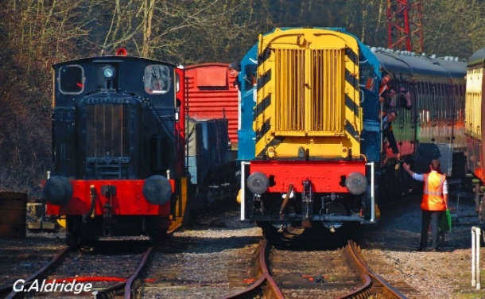
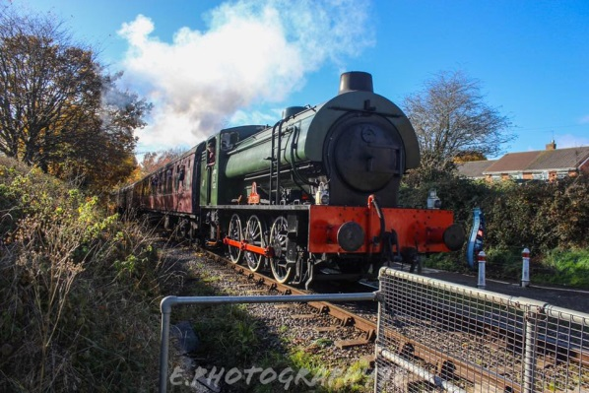
Hunslet Austerity 0-6-0ST WD 132 'Sapper'
• Andrew Barclay 0-4-0DM WD 70043 'Grumpy'
• Barclay 0-4-0DM 426 'Kingswood'
• Ruston Hornsby 0-6-0DH No 429 'River Annan'
• BR Class 08 0-6-0DE 08202

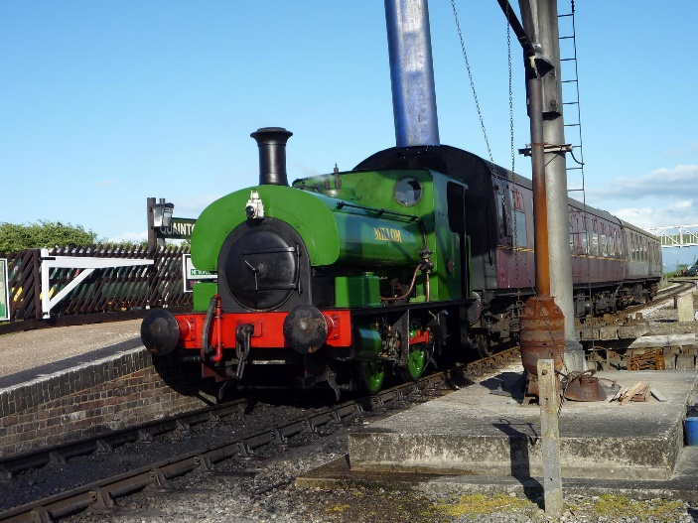

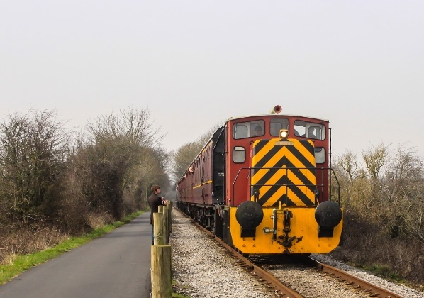

A special timetable will be in operation during this event along with slightly enhanced fares.
Income from train fares and your support will help the overhaul of our own resident industrial steam locomotive, Robert Stephenson & Hawthorn 0-6-0T No. 7151

